**DSA CHEET 450**

**Question 1**

**Reverse a string**

**Sol 1**

The reversed() function returns an iterator that accesses the elements in the string in reverse order. You can then use ''.join() to join the characters back into a string. It is a string method and is called on a separator string, which is inserted between the elements of the iterable being joined

Strings are immutable can not directly change them

**Q2 Finding min and max in Array**

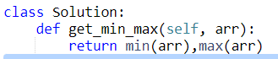

**Question 3 Finding** Kth **min in the Array**

--Simple sort the array and return k-1 element of array

**Question 4 Sorting 0s 1s 2s in array**

**Sol1 Count Sort**

Count the no of 0s 1s 2s then place them in the array. Time Complexity is 0(n) but it requires two passes In-place and stable

**Sol 2 Dutch Algorithm**

Use Dutch Algorithm, it requires one pass of the array. In-place and not stable

Suitable for only three elements

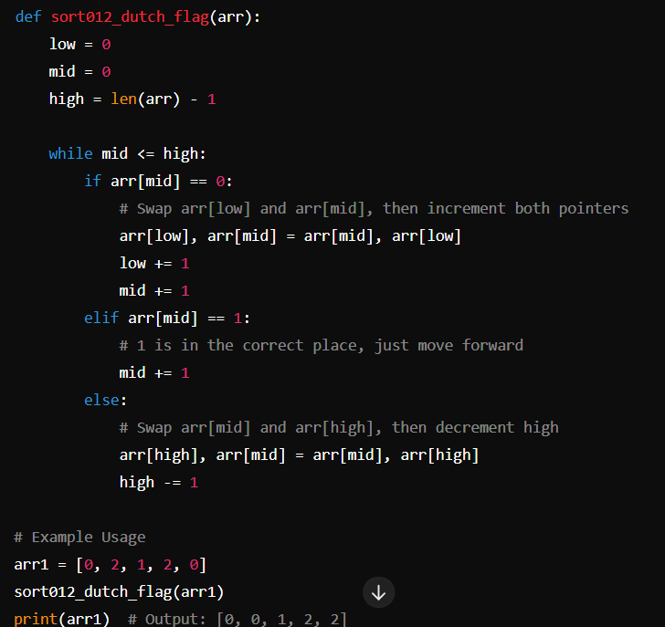

**Question 5 Segregating negative numbers in array**

Count the number of positive and negative elements in array. Then start saving the negative numbers from the index equal to number of positive elements in array.

**Question 6 Returning the size of union of two list**

Simply add both lists and make them a set and return the length of set